Restrict User Access to Windchill Users
Schindler CRD Applications

Exported on 2025-10-17 05:03:13

Table of Contents

1 Prerequisite: 4
2 Reference: 5
3 Procedure: 6

- Prerequisite:
- Reference:
- Procedure:

Prerequisite:
- Need admin access on Windchill Application server.
- Windchill should be installed and in running condition.

Reference:
- Please refer the below article.
URL: Article - CS236329 - How to restrict non-admin users from login to the Windchill

Procedure:
- Take backup of the below file.
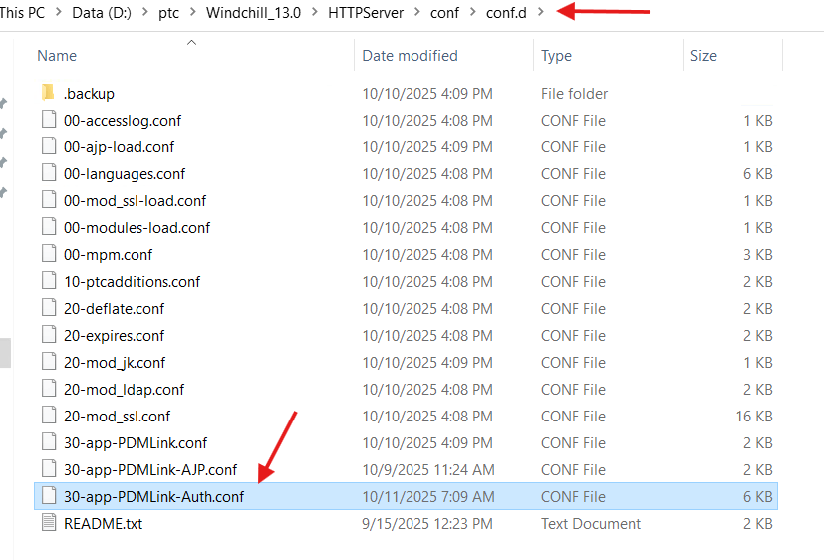

2. Update the entries as shown in the below file to provide the access only to the list of users.
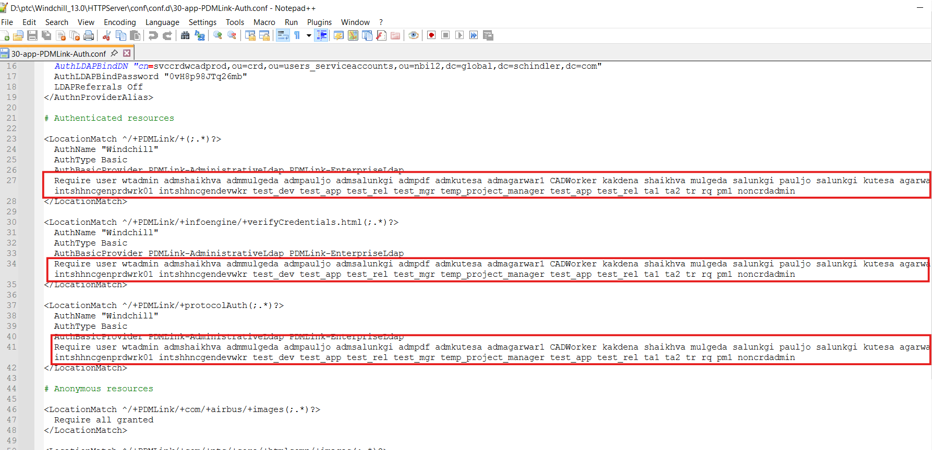

3. Save changes and restart Apache.
4. To provide access to all the Windchill users just replace the above file with the backup file that was taken before update.

